Fisher-Price Bright Beats Dance & Move BeatBo

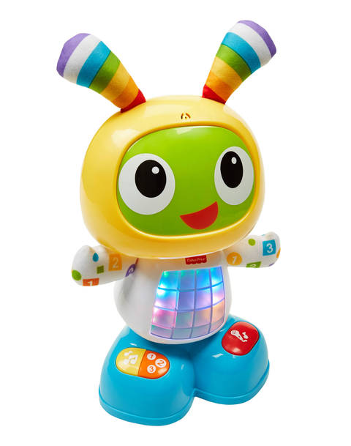

**Three modes – Dance ’n Move, Learning & Games, and Customized Sing-Along – “grow” with baby to make him a forever friend for years to come. And through all the play, BeatBo’s introducing baby to letters, colors, counting, music, cause & effect and much more.**

The switch controller is configured for the three switches on the feet:

1. Dance & Move – Yellow button
2. Learning & Games – Orange button
3. Customized Sing-Along – Red button

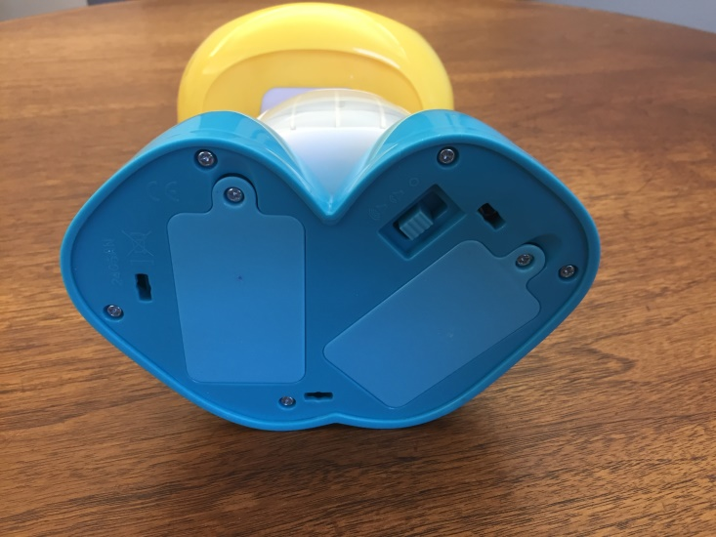Bottom before opening

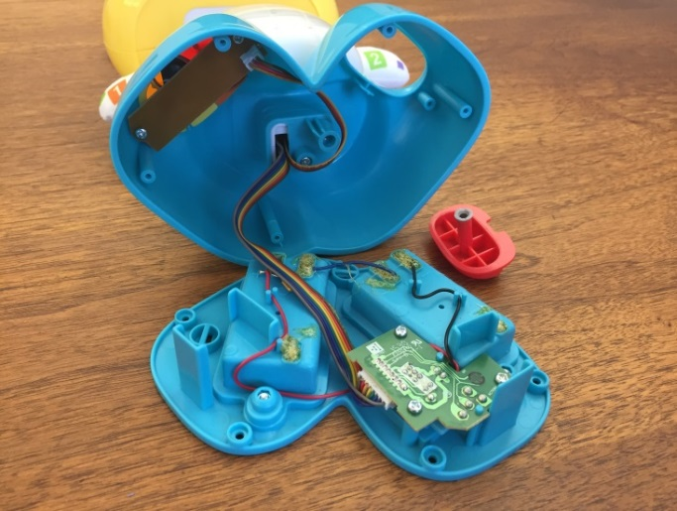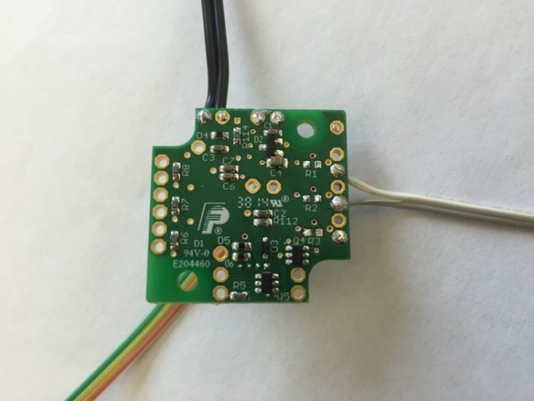

Bottom open Switcher Controller

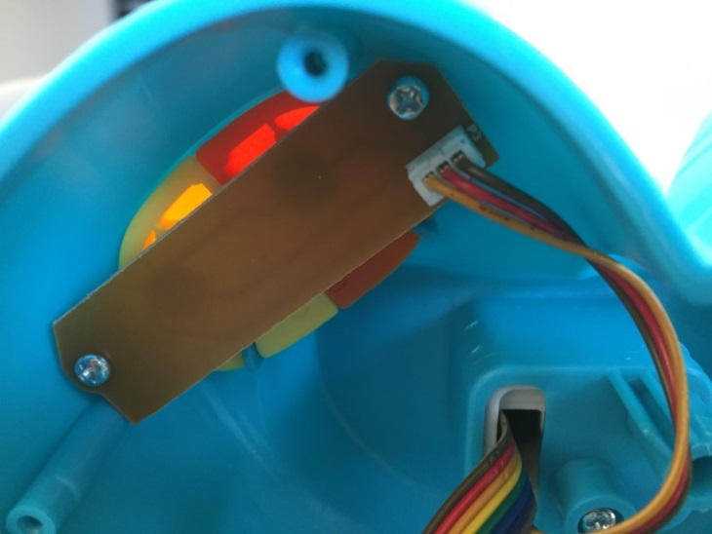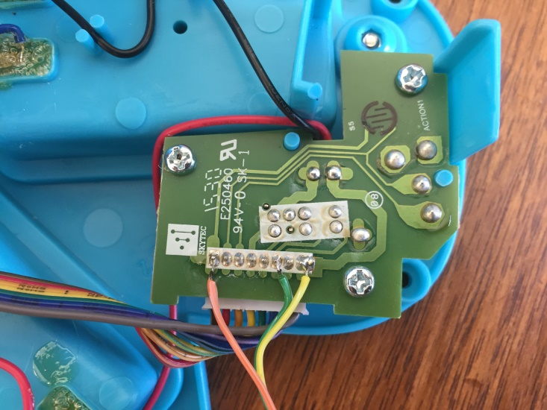Power Supply (Don’t connect here!) Two pushbuttons on right foot

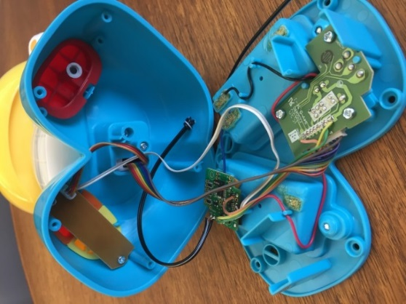 Don’t connect to power supply board. Open torso and connect to computer board. Power the switch controller from Vcc and GND. Determine if switches are common GND or common Vcc. Take switches from computer board.

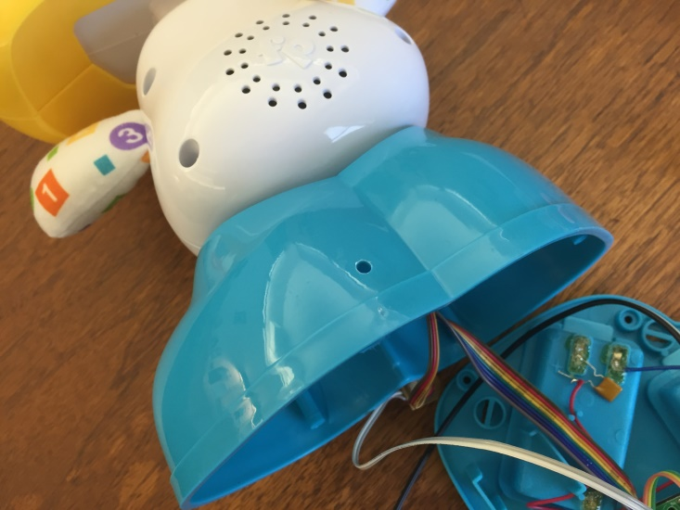 Need to drill hole for the phone plug wire. Tie a knot in the wire for strain relief.

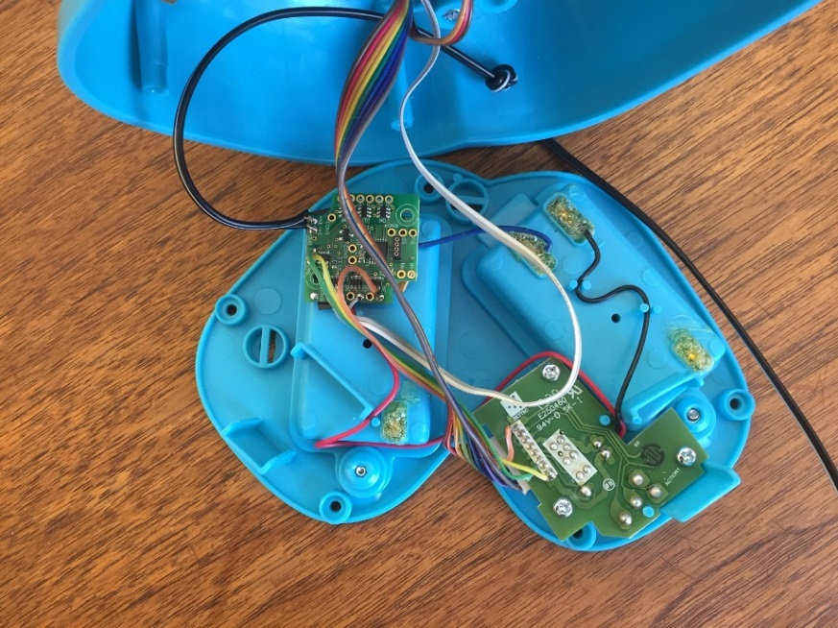 Mount the switch controller (double-stick tape?) in a convenient location.